Prueba de capture limpia Windows 11 24h2

Custom [Settings]

Priority=Default

Properties=MyCustomProperty

[Default]

OSInstall=yes

oscapture=yes

SkipCapture=NO

SkipAdminPassword=YES

SkipProductKey=YES

SkipComputerBackup=NO

SkipBitLocker=YES

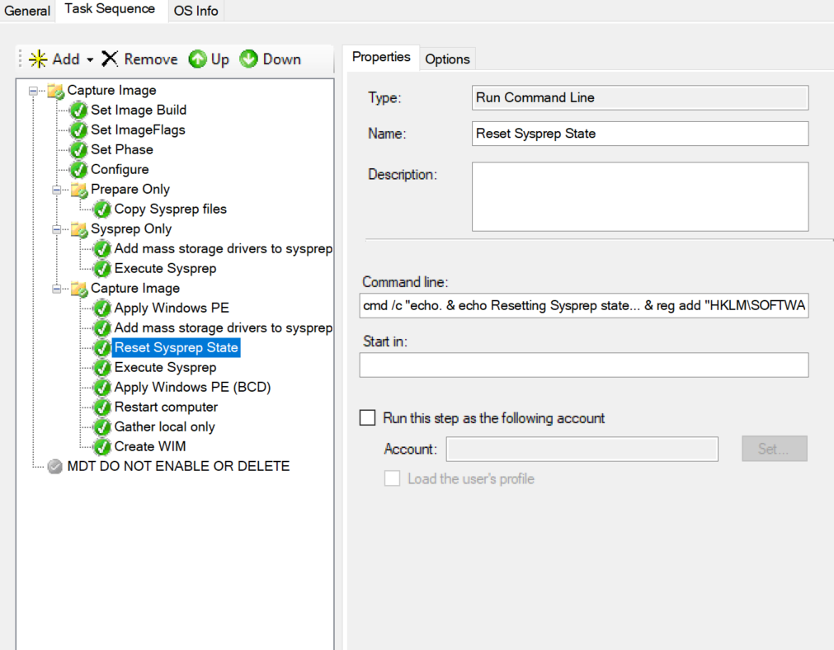

Comando

Reset Syspre state

cmd /c "echo. & echo Resetting Sysprep state... & reg add "HKLM\SOFTWARE\Microsoft\Windows\CurrentVersion\Setup\State" /v ImageState /t REG_SZ /d "IMAGE_STATE_GENERALIZE_RESEAL_TO_OOBE" /f & C:\Windows\System32\Sysprep\sysprep.exe /generalize /oobe /shutdown /quiet"



